***TASK 1:***

#include <iostream>

//insert the values in heap

using namespace std;

void insert(int* a, int i, int n)

{

int j, temp;

temp = a[i];

j = 2 * i;

while (j <= n)

{

if (j < n && a[j + 1] > a[j])

{

j = j + 1;

}

if (temp > a[j])

{

break;

}

else if (temp <= a[j])

{

a[j / 2] = a[j];

j = 2 * j;

}

}

a[j / 2] = temp;

return;

}

//max the values in heap

void max_heap(int* a, int n)

{

for (int i = n / 2; i >= 1; i--)

{

insert(a, i, n);

}

}

//Level order traveresal

void level_order(int arr[], int n)

{

for (int i = 1; i <= n; ++i)

{

cout << arr[i] << " ";

}

}

int main()

{

int n, i, x;

cout << "enter no of elements of array :";

cin >> n;

int a[20];

for (i = 1; i <= n; i++)

{

cout << "Enter element " << i <<" :";

cin >> a[i];

}

max_heap(a, n);

cout << "Max Heap in Level order traversal"<<endl;

level_order(a, n);

cout << endl;

}

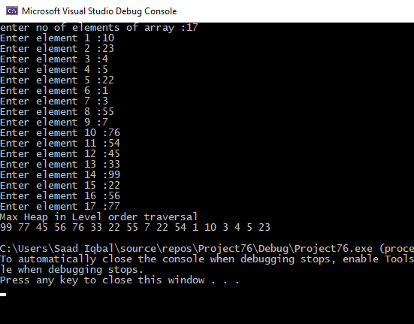

***TASK 2:***

#include <iostream>

using namespace std;

//insert the values in heap

void insert(int arr[], int n, int root)

{

int largest = root;

int l = 2 * root + 1;

int r = 2 * root + 2;

if (l < n && arr[l] > arr[largest])

{

largest = l;

}

if (r < n && arr[r] > arr[largest])

{

largest = r;

}

if (largest != root)

{

swap(arr[root], arr[largest]);

insert(arr, n, largest);

}

}

//Sorting heap

void heapSort(int arr[], int n)

{

for (int i = n / 2 - 1; i >= 0; i--)

{

insert(arr, n, i);

}

for (int i = n - 1; i >= 0; i--)

{

swap(arr[0], arr[i]);

insert(arr, i, 0);

}

}

//Display array

void displayArray(int arr[], int n)

{

for (int i = 0; i < n; ++i)

cout << arr[i] << " ";

}

int main()

{

int n;

cout << "Enter the size of the array :";

cin >> n;

int * heap_arr = new int[n];

for (int i = 0; i < n; i++)

{

cout << "Enter Element " << i + 1 << " :";

cin >> heap_arr[i];

}

cout << "Array before sorting " << endl;

displayArray(heap_arr, n);

cout<<endl;

heapSort(heap_arr, n);

cout << "Array after sorting " << endl;

displayArray(heap_arr, n);

}

